**Update Customer Overview**

**Update Customer**:

**Add Action Column**:

Here we will add a new column called action. In this column we add an update link for each customer. By using this link user can update the customer information.

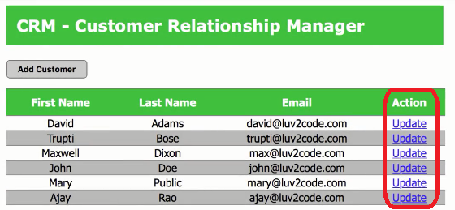

**Click on Update Button**:

When user click the update link program open the "**customer-form**" JSP page with fill up the related field.

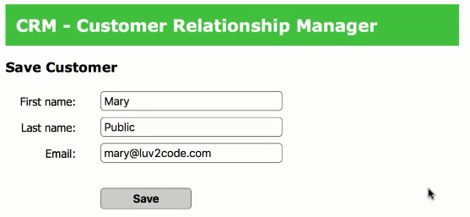

**Update Information**:

Here we can change our information. After change the information if we click the "**Save**" button the update information saves in the database. Here we change the Last Name from Public to Zeno and Email [mary@luv2code.com](mailto:mary@luv2code.com) to [happymary@gmail.com](mailto:happymary@gmail.com)

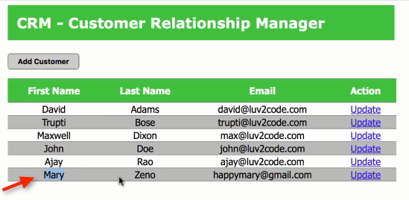

Update Customer Overview